Volunteer Signup Direction
Individual Volunteer:
- Volunteers will go to the Volunteer Lebanon Portal at the bottom of the Day of Caring page page on the United Way of Lebanon County website.

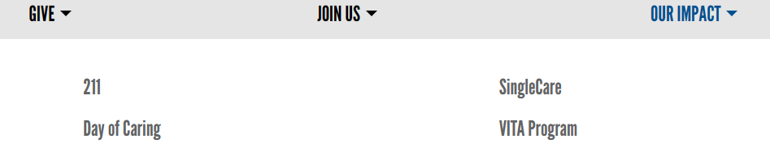
- Click on the Volunteer Portal
- Sign up and fill out the informational prompts to the best of your ability and it will build your personal Volunteer Lebanon account.
- Volunteer opportunities on the left hand side is where the Day of Caring opportunities are posted from each agency:
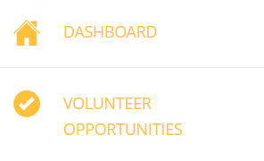
  - Once you click on a volunteer opportunities, you will go to “Filter By” and click “initiatives”. Once you click initiatives, you will then select “Day of Caring 2024”
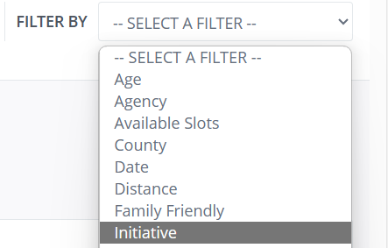
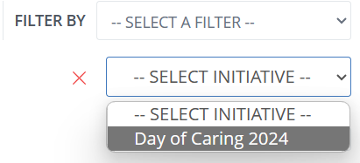
  - Once you have the volunteer opportunities aligned with Day of Caring 2024 you can select the opportunity you want by clicking on “View Details”
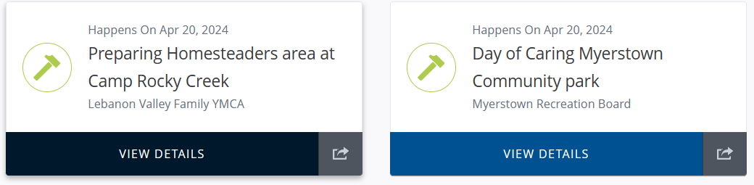
  - Once you click on view details in the top right corner there will be a button that says “Respond” in the top right corner.
  - There will be a prompt that allows volunteers to add additional information if they would like. Once finished, volunteers will then select “Submit Volunteer Opportunity Response”
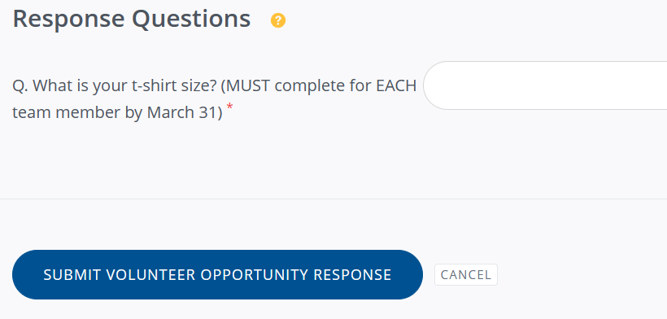
  - Once the volunteer response has been submitted, your spot has been saved and there will be a confirmation email sent out thanking you for registering for this volunteer opportunity.

Volunteer Team Signup Direction
Team Signup:
- https://center.freshdesk.com/support/solutions/articles/36000434278-teams-a-guide-for-volunteers#Creating-a-new-team
- Make sure all team members are signed up on volunteer Lebanon with their own account. If they are not and you add them as a group member they will be prompted to create an account through the email you use.
- Click on the volunteer opportunity that you would like to sign up a group for and click on the “Respond as a Team”
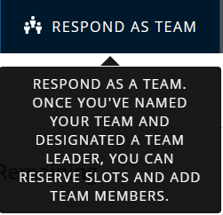
  - Add Each Team members name and current email used for their volunteer account.

- Once you add team members, there will be an option to make someone (yourself or whoever) a team leader.
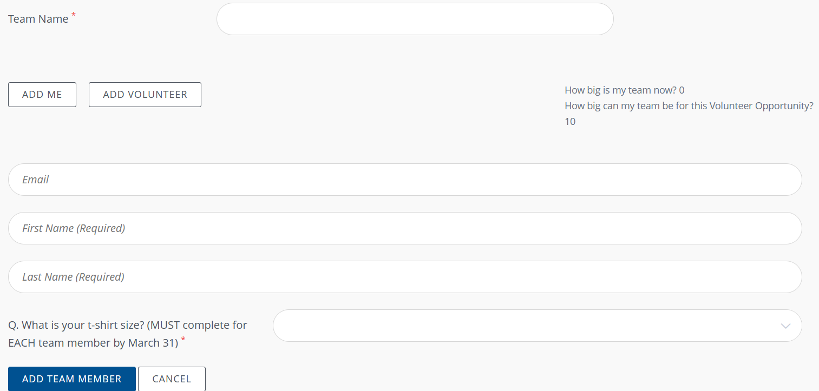

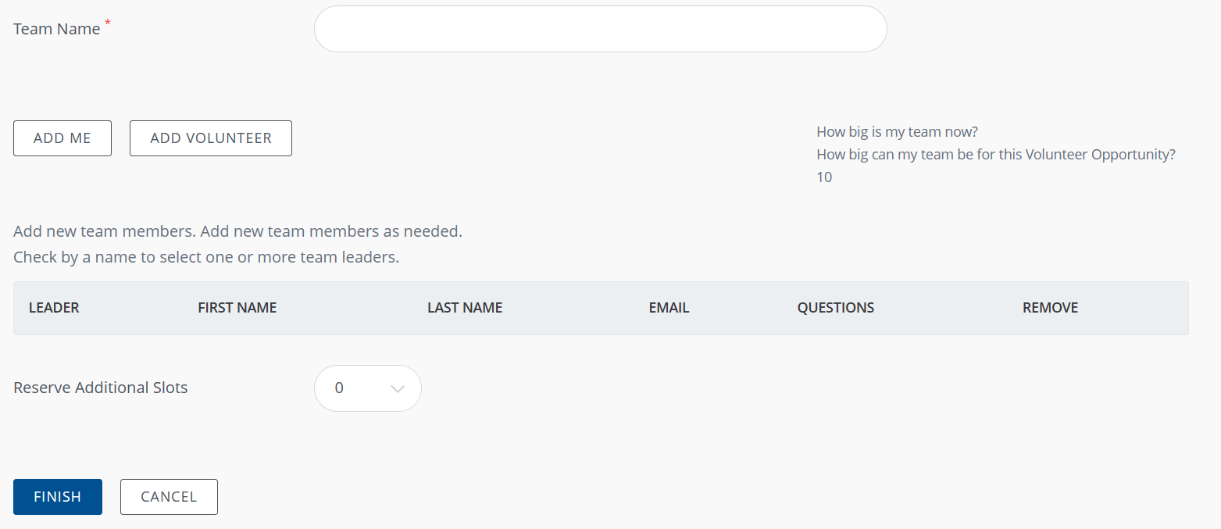
- Once all members of the Team have been added click “Finish” and your spots will be reserved and your team is registered.

Thank you for signing up for United Way of Lebanon County’s 2024 Day of Caring!

